There are a lot of websites with questionable design choices floating around. Geocities/Tripod sites are… no longer with us, so I went to a comedy website, Something Awful (Motto: “The Internet Makes You Stupid”) for inspiration. There are often weekly features there which highlight Crazy Internet Stuff, and I decided to take one of the highlighted sites, “STRETCH ARMSTRONG WORLD” as my example.

It’s located at, funnily enough, <http://www.stretcharmstrongworld.com>.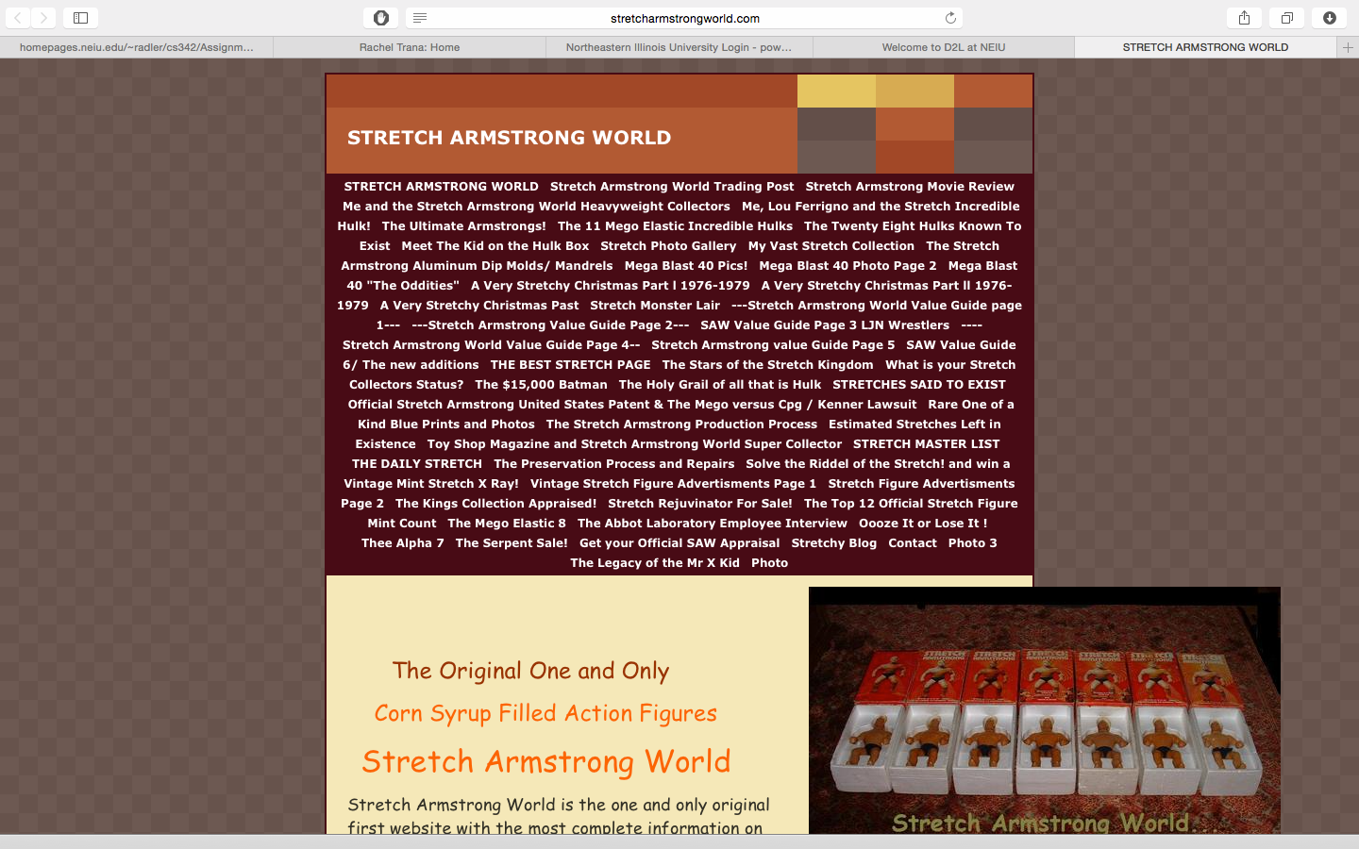

It’s not horribly designed, but I feel there is plenty room for improvement there. The color scheme seems to fit the whole Stretch Armstrong theme, so it stays. Normally these colors wouldn’t really fly, but I think they actually work, in a 70’s kind of way.

The first thing I would change is the navigation bar, at the top. It’s ludicrously large and doesn’t seem to be sorted into any sort of easily recognizable pattern or hierarchy. You’d have to read through the entire list to find what you want, instead of, say, having all the photo galleries in the same place.

The second thing is the page width. It seems to be using a centered frame, which is nice if the left and right sides of the frame are near the sides of the screen. This page was last updated in 2009 and screen resolutions were smaller than they are today. Some scalability for different screens would make the whole thing look so much better.

Thirdly, the formatting for the main page body is lacking. Part of this is because of the left-justified text and what I assume is the pictures busting out of the frame. This could be a conscious choice, kind of like a Post-It tab off the side of the page, but I think the space directly below the pictures there is wasted and it could look better.

These aren’t the only things wrong with the page! The visual style isn’t consistent between all pages:

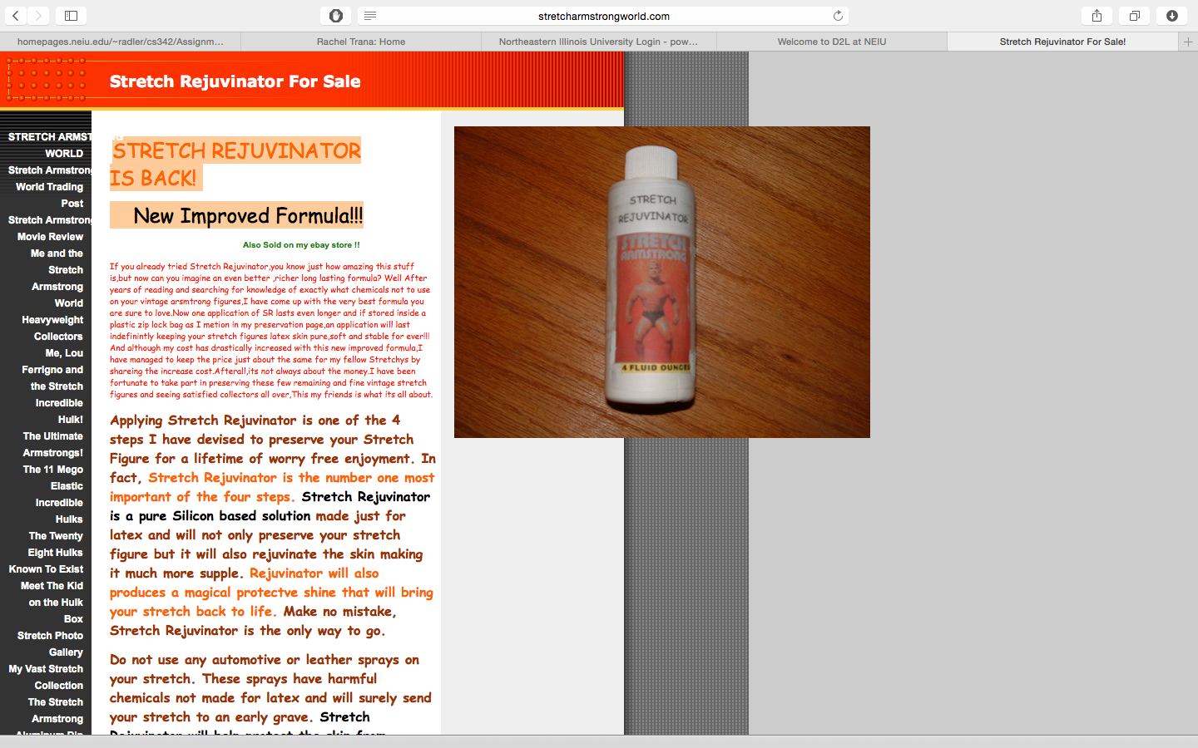

And as we can see, not every picture has that Post-It thing going on, which makes me think that it’s just pictures popping out of the frames in the main and other pages that use that style.

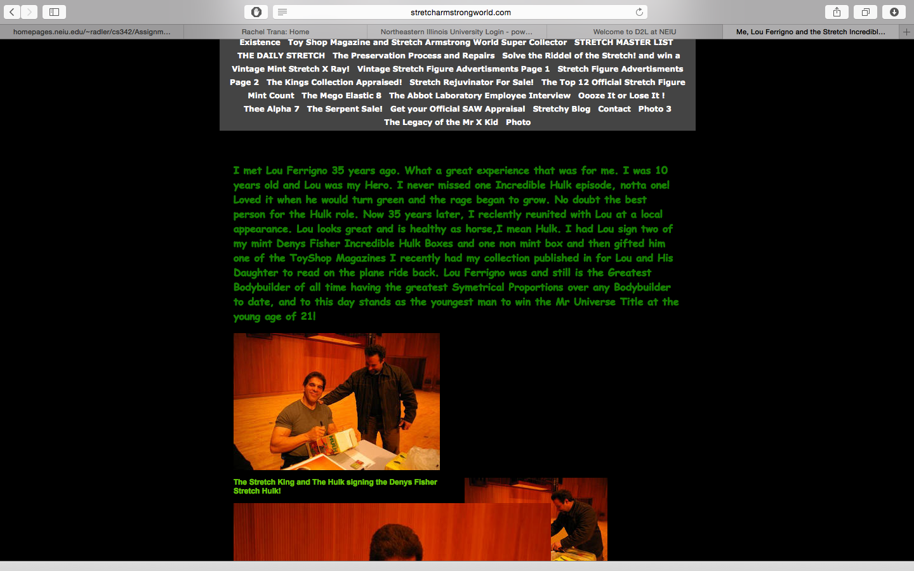Now, I don’t think I can re-do this guy’s entire website, but I’m going to rejigger the front page in a way that I find more aesthetically pleasing. It mostly involves setting the CSS settings to scale properly, and it looks like this: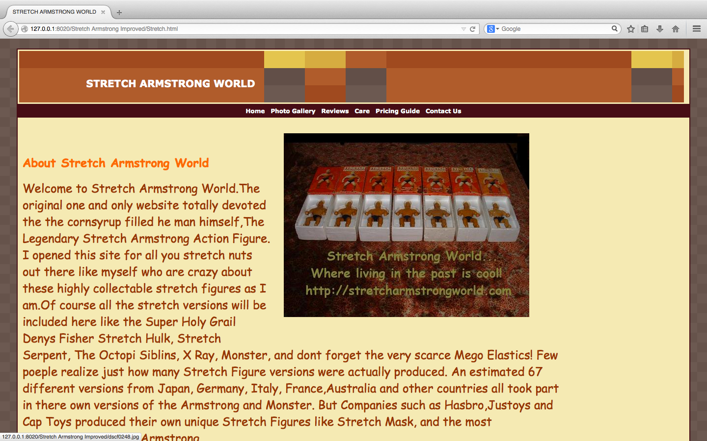

The header is modified a little bit, it uses a gif and I set it to repeat horizontally, I’m not a great picture guy, but I would have designed it to scale properly, as I would

The links are cleaned up (I removed a lot of them, honestly, if I were to do a complete overhaul of this page there would be a more intuitive branching system to get you where you wanted to go with 3 or less clicks.)

I also tried to modify the picture and text areas, and did what I think is an okay job, considering the original page. It’s HTML 4.0 Transitional, and was not very easy for me to interpret. This page is obviously a guy’s hobby page and he was obviously self-taught. I wouldn’t have made it the way he did.